**Customer Churn Analysis**

**Overview:**

Over the certain period, some of the customers who used to purchase services on multiple lines, phone, online backup, device protection, tech support and Streaming TV and movies have left within the last month i.e they have churned, there are other customers who are still purchasing services every month.

**Objective:**

The objective of my analysis is to determine and predict the behaviour to retain the customers based on the historical data.

**Analysis:**

I began my analysis by performing the data wrangling techniques using python3 followed by determining the key factors. From my analysis of the dataset, the churn column is the dependant target variable.

By eliminating unwanted columns, redundant records and missing values, I was able to determine the count of the types of contracts which ranged from month-to-month, one-year to two-year contracts. The results are shown in the graph:

From this graph, we can observe that most customers prefer to purchase for services more on month-to-month rather than preferring with one-year or two-year contracts. In fact, to dive deeper in this graph, we can also observe that majority of the customers did not churn when they are in month-to-month contracts. We can also see that there were more than 1500 customers who did churn from month-to-month contracts compared to customers who churned from one-year and two-year contract services.

To proceed further, I also determined the number of customers who churned and did not churn as well. The graph is shown:

As shown in the graph, most of the customers ranging more than 600 did not churn from month-to-month, one-year and two-year contracts. There was indeed a certain count of customers who churned ranging from 350 to 500 during the initial periods.

I was even able to see how many customers churned from each of the services provided such as internet service, Online security, Online backup, Device protection and tech support. The results are shown in the following graphs below:

This graph shows the count of customers who churned and did not churn under internet services. As we can see, majority of the customers, which is about 1250 of them churned particularly from fiber optic services compared to DSL and no internet services. On the other hand, approx. 1750 to 2000 customers did not churn from DSL and Fiber optic services while the rest of the count did not churn from no internet services. This shows that customers prefer going ahead with DSL services and fiber optic services.

Looking at the graph for online distribution services, we can see that customers have preferred to not churn and remain in business by not taking online security services. About 2000 customers have not taken online services and did not churn while the 1750 of the customers preferred taking online services while only 250 of the customers churned. About 1250 customers did not take internet services with online security but were paying monthly expenses for the same. The remaining customers churned. This shows that customers do not prefer taking online security services and some customers prefer going with online security services.

The results are shown in the graph:

Let’s look at the graph that shows the count of customers who churned and did not churn from online backup services. As shown in the graph, we can see that between 1750 to 2000 customers preferred going with online backup services while 500 customers churned. We can also see that 1750+ customers did not take up online backup services while approx. 1200+ customers churned from online backup services. This shows that customers prefer going with online backup services compared to not going ahead. The graph is shown below:

To dive into the graph for device protection, we can see the graph that shows the customer count who purchased on device protection and some customers who later churned. Likewise, we can also see customers who did not purchase device protection and some customers who later churned as well. We can see that 1700+ customers purchased device protection services as well 1700+ customers who did not go for device protection services. This shows that it depends on customers who decide whether they need device protection or not.

Finally, let’s look at the graph that shows the customer count who churned and did not churn in tech support services. We can see that 2000 customers did not need tech support services while approx. customers churned which showed they either needed tech support or they did not want at all. We can also see 1750 customers needing tech support services while 250 customers churned. This shows that customers did not see the need for tech support and only needed if there was a necessity.

I was also able to see how customers preferred making transactions for purchases on these services, we can see the proportions below:

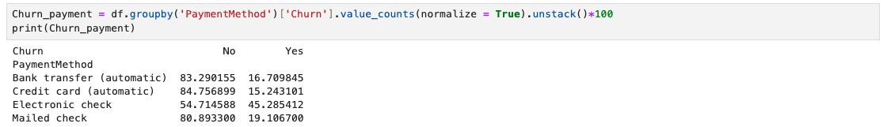

We can see that approx. 85% of customers preferred paying through automatic payments such as bank transfers and credit card. The remaining proportion of the customers churned. Most of the customers prefer making automatic payments while only some of the customers prefer going ahead with payments using cheques. We can also see that some customers did churn as well.

Looking at the trend overall, we can see that majority of the customers did not churn from services while only some of the customers churned.

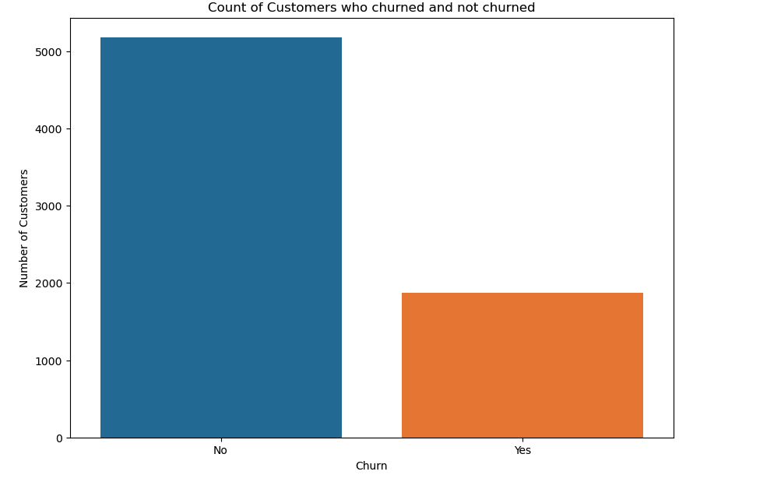

**Recommendation and conclusion:**

From the overall analysis, we can conclude and infer that customers prefer taking up services only if they see the need for it. Some customers later churn if they do not find the services satisfying their needs or if they don’t see the expected results. They also churn if their expense is out of their budget so due to reallocation, it can be sometimes that they churn away. For the company’s perspective to regain lost customers, they can focus on lowering monthly prices, bringing flexible features that could bring potential customers back and in fact target new customers as well. By introducing flexible payment plans, making tenures convenient for customers to reconsider and build businesses with. In that way, we can expect the churn proportion to drop down making the customer count with the business to increase. Proper customer survey and feedback calls result in understanding what the customers face and focus on resolving issues. In the next few years, we can expect a spike in customer count thereby lowering the churn proportion.